‘Closing the Word Gap at Netherton Moss’

‘Language opens doors. It unlocks the world of reading and the imagination, the excitement of writing, the capacity to explore new subjects and releases children’s potential to learn and grow as an individual. It underpins progress, impacts on attainment throughout primary and secondary years, affects self-esteem and behaviour and plays a huge role in children’s life chances.
Without enough language – a word gap – a child is seriously limited in their
enjoyment of school and success beyond.’
Oxford Language Report 2018.

At Netherton Moss, we understand that this issue can affect all children, and the word gap can be present throughout any child’s education and beyond. Research tells us that language variation is a complex issue and it is therefore impossible to attribute it to one specific cause.

We prioritise the teaching of communication and language. Our nursery and reception teachers are currently being trained as Language Leaders which is having a positive impact on children’s communication and language development. Other strategies used widely in the EYFS to encourage children’s vocabulary and language development are – circle time, stories, songs and rhymes, role play, chatty bags, running commentaries, the modelling of language and open-ended questioning, reading buddies, word of the week, wow words, talk partners, show and tell, news time, guided reading and forest school.
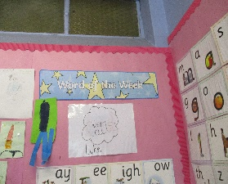
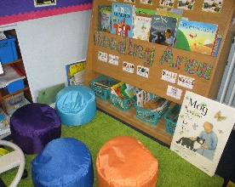

In Key Stage 1 – strategies include, reading a daily class reader to children, word walls, key words and working walls in classrooms, trips to the local library, class trips, visitors including Zoo Lab and drama groups, independent reading, whole school book studies, talk partners, vocabulary games eg true or false and who am I, modelled writing, reading buddies, RWI and guided reading activities and rewards for reading.
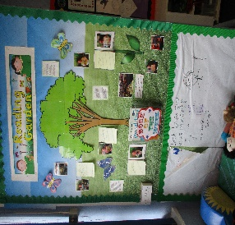
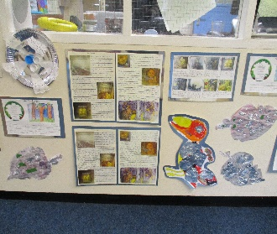
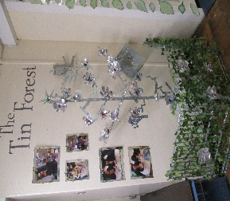

In lower Key Stage 2, strategies include hot seating, freeze frames, conscience alley, children’s use of dictionaries and thesauruses, children’s reflections on News Round, adults modelling standard English, discussions in PSHE, teachers having conversations with children over lunch, reading to children, anagram challenges, all adults within classrooms encouraging children to use full sentences and to repeat new vocabulary and giving children time to talk.

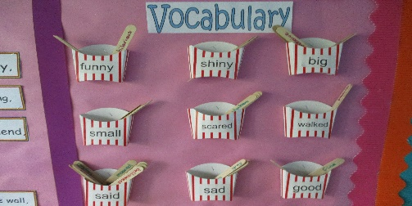

In upper Key Stage 2, children are given opportunities to present their own news/views to the class, children take part in discussions about current affairs following Newsround, and enjoy listening to the class reader, they also enjoy reading their own choice of texts, intervention groups focus on reading and comprehension, children are encouraged to speak in complete sentences to explain their thinking and open-ended questions are asked. Children have recently explored the programme ‘Shades of Meaning’ to research more interesting vocabulary.

Teachers are consistently looking for new innovative strategies to improve children’s language skills and vocabulary.

‘Good vocabulary knowledge is related to growth in reading comprehension over time; children with better vocabulary have better reading comprehension and their
comprehension improves more over time.’
Professor Kate Cain Lancaster University 2017


