Netherton Moss Primary School Year 1 School Curriculum Highlights Autumn Term 2024

These are the topics and areas of the school curriculum that the children in Year 1 will be studying this term. As you can see there is the key learning intentions for each area and some ideas for ways in which you could help support this learning at home. If you have any further questions about what is going on in our lessons, then please call in at the end of the school day and find out more.
English | Maths | Science | ICT & Computing | Art & Design | History
We’re all going to the zoo… | Maths Mastery | Animals including humans | We are Creators | Self Portraits | Guy Fawkes and The Gunpowder Plot
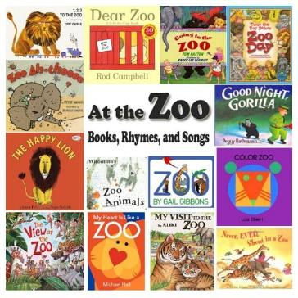 | 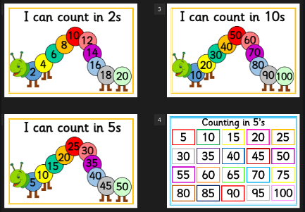 | 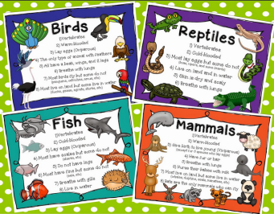 | 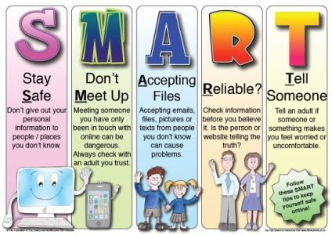 | 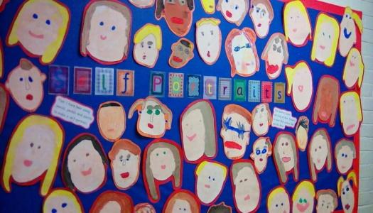 | 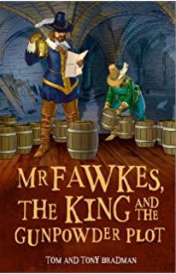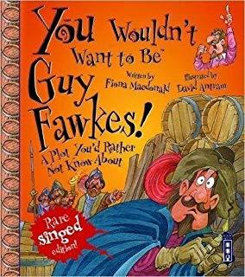
In School: | In School: | In School: | In School: | In School: | In School:
- Listening to and discussing a wide range of poems, stories and non-fiction at a level beyond that at which they can read independently  - I can sequence sentences to form short narratives  - Write simple sentences that can be read by themselves and others. | - Read and write numbers to 100 in numerals.  - Read and write numbers from 1 to 20 in numerals and words.  - Begin to recognise the place value of numbers beyond 20 (tens and ones).  - Add and subtract one-digit and two-digit numbers to 20, including zero | - I can describe the key features of animals  - I can name a range of animals which include animals from each of the vertebrate groups.  - I can sort and group animals using similarities and differences  - I can find out what animals eat, including talking to experts e.g. zoo keepers etc.  - I will go on a visit to Chester Zoo | - I can use technology to create, organise and store content.  - I can log onto the computers and use a mouse  - E-Safety  - I can keep my password private.  - I can tell you what personal information is.  - I can tell an adult when I see something unexpected or worrying online. | - I can develop a wide range of art and design techniques in using colour, pattern, texture, line, shape, form and space  - I can record and explore ideas from first hand observations. | - I can find out about Guy Fawkes and begin to recall the facts.  - I can find out about the main events of the Gunpowder Plot.  - I can find out about how the Gunpowder Plot is remembered.
At Home: | At Home: | At Home: | At Home: | At Home: | At Home:
Ask the children to retell the story of Dear Zoo. Visit the library and borrow books about different animals to share at home. | Look for opportunities to count objects at home and when outside. Practice recognising numbers in the local areas and at home, house numbers, bus numbers etc. Practice adding together small groups of objects at home. | Borrow and share book from the library about animals.  Decide upon a favourite animal and research a fact file about the animal.  At half-term, use your free family ticket and visit Chester Zoo ask your child to recall their visit. | If you have a smartphone or tablet use it to search for pictures of your favourite animals and if it has a camera function, use it to take photographs. Download the Crazy Talk Animator App and use it to make your animal pictures move and talk. | Provide plenty of opportunities for your child to draw, colour and create at home using a wide range of different pens and pencils, scissors and paper. Encourage them to use the correct grip and create from what they see and from their imagination | Talk about Bonfire Night and ask your child to explain what it is that we’re remembering on November 5th and retell the story to you. Talk about the importance of Firework safety especially for children and pets.
Religious Education | Music | PSHE | Physical Education | Design & Technology | Geography
Belonging | Charanga | Mindfulness & Resilience | Fundamental Skills | Design & Make Fruit Skewers | Our Local Area
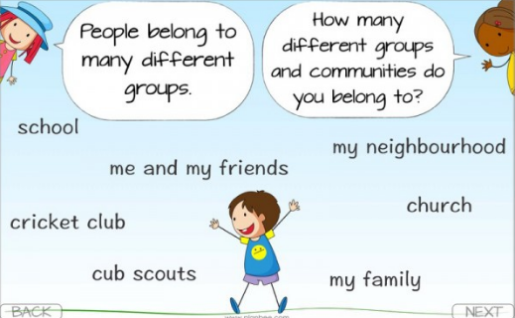 |  | 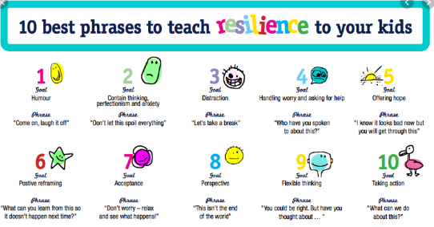 | 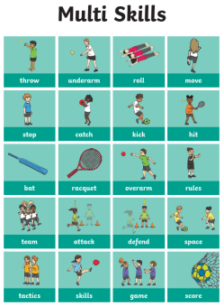 | 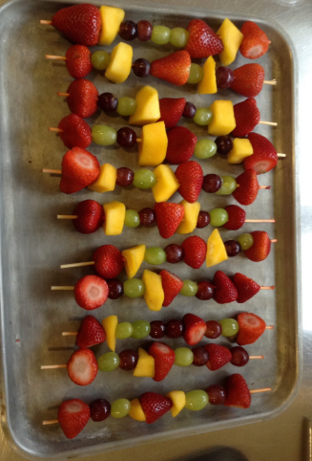 | 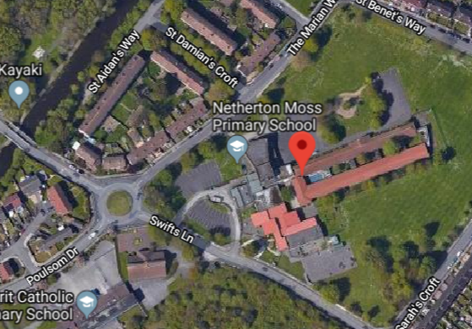
In School: | In School: | In School: | In School: | In School: | In School:
- What does it mean to belong?  - Belonging to a family.  - Belonging to Christianity | - I can take part in singing songs  - I can copy sounds  - I can create a sequence of sounds  - I can respond to different moods in music saying how music makes them feel. | - I can understand the concept of risk.  - I know who and how to tell.  - I can recognise and manage emotions within a range of relationships.  - I can recognise risky or negative relationships bullying. | - Travelling - Running, hopping, skipping, galloping.  - Travelling with an object i.e. beanbag, ball,  - Sending - Aiming at various targets using different equipment (beanbag, ball, quoits, shuttlecock etc.).  - Receiving - Catching a ball. | - I can use pictures and words to convey what I want to design/make.  - I can say what I like and do not like about items I have made and attempt to say why.  - I can group familiar food products e.g. fruit and vegetables.  - I can cut, peel, grate, chop a range of ingredients safely and hygienically. | - I can use maps and other images to talk about everyday life e.g. where we live, journey to school.  - I can use large scale maps and aerial photos of the school and local area.  - I can look down on objects and make a plan e.g. of the classroom or playground
At Home: | At Home: | At Home: | At Home: | At Home: | At Home:
Discuss and recall family times and family members. Discuss what it means to be part of a family made up of relatives and friends who support one another. | Listen to music and sing-along whenever possible and encourage the children to have favourites. | Talk about the rules there are at home and how these help to keep people safe and happy. Encourage your child to use calming strategies and to be open about worries and concerns. | Take every opportunity for to play outside, visiting the park and the playground in order to get daily exercise to build stamina and resilience and get fresh air and the exercise needed to sleep well. | Practice cutting, chopping a range of fruit and vegetables at home. Borrow a children’s cookery book from the library to share, read and make. Discuss family member’s favourite fruits with your child and try preparing and tasting a wide range. | As you journey to and from school, look for the different road names and discuss geographical features such as the canal, bridges and roundabouts. Use a map to trace the route as you travel.
More detail as to content of the Year 1 Curriculum can be found on the school website.

