Netherton Moss Primary School Year 2 School Curriculum Highlights Autumn Term 2019

These are the topics and areas of the school curriculum that the children in Year 2 will be studying this term. As you can see there is the key learning intentions for each area and some ideas for ways in which you could help support this learning at home. If you have any further questions about what is going on in our lessons, then please call in at the end of the school day and find out more.
English | Maths | Science | ICT & Computing | Art & Design | History
Talk for Writing | Place Value & Addition and Subtraction | Living things in their Habitats | Esafety & ICT Skills | Nature Sculptures | The History of Travel and Transport in Liverpool
Fiction:  (Change Tale) - Wanted: The Perfect Pet  (Description) -The Elves and the Shoemaker  Non-fiction:  (Instructions) - How to Wash a Woolly Mammoth | 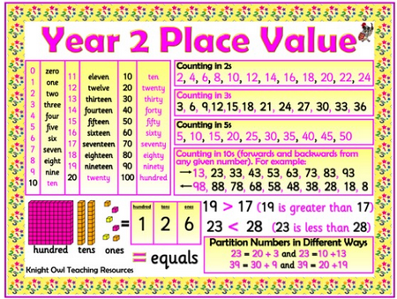 | 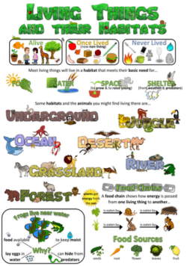 | 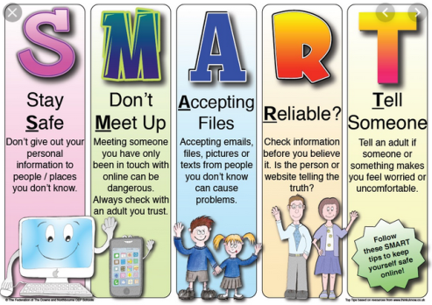 | 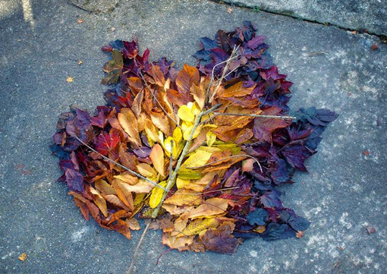 | 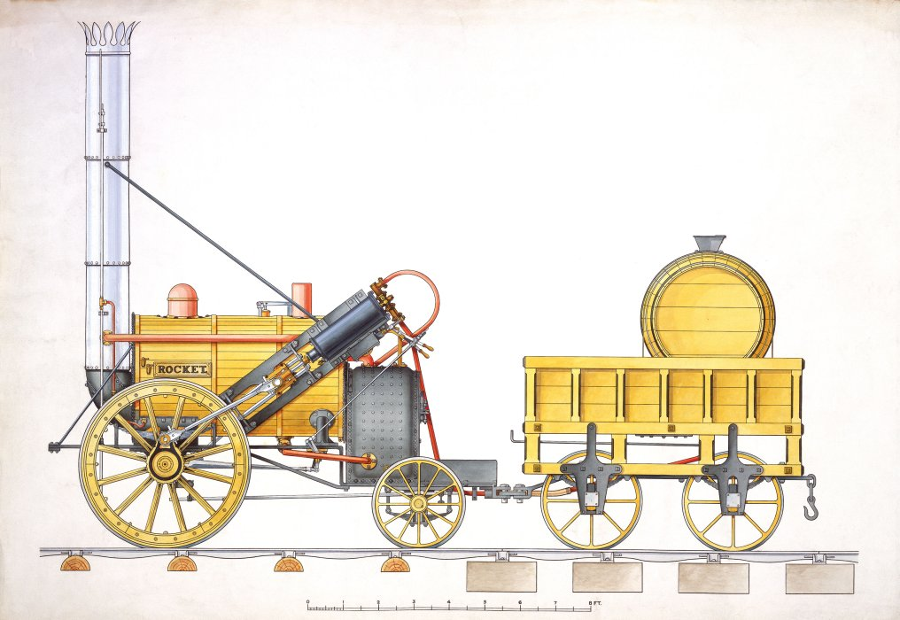
In School: | In School: | In School: | In School: | In School: | In School:
- I can read aloud books closely matched to my improving phonic knowledge, sounding out unfamiliar words accurately.  - I can re-read these books to build up my fluency and confidence in word reading.  - I can plan or say out loud what I am going to write about.  - I can write simple, coherent instructions.  - I can use adjectives to up level my sentences.  - I can demarcate most sentences in my writing with capital letters and full stops. | - Count in steps of 2, 3, and 5 from 0, and in tens from any number, forward and backward.  - Read and write numbers to at least 100 in numerals and in words. Find 1 or 10 more or less than a given number.  - Recognise the place value of each digit in a two-digit number (tens, ones).  - Add and subtract numbers using concrete objects, pictorial representations, and mentally. | - I can find a range of items outside that are living, dead and never lived.  - I can name a range of animals and plants that live in a habitat.  - I can talk about how the features of these animals and plants make them suitable to the habitat.  - Using a food chain I can explain what animals eat. | - I can use a website to search for information  - I can begin to identify possible dangers online  - I know when to ask an adult for advice about accessing a website  - I can login to the computer and select an application.  - I can logout and save my work appropriately | - I can construct a nature sculpture, exploring a range of media.  - I can list natural materials that are easily found in the local environment  - I am able to describe the work of Andy Goldsworthy.  - I can understand how to work safely. | - I can find out some of the different ways in which travel and transport has changed from past to present.  - I can make comparisons between past and present transport and travel in Liverpool.  - I can understand how people travelled to Liverpool by boat and the importance of the port and docks.  - I can recognise evidence of the past in the local canals and understand why they were created.  - I can find out about George Stephenson’s inventions and the Rainhill trials.  - I can place some significant events in the history of travel and transport in Liverpool in chronological order using pictures and labels.
At Home: | At Home: | At Home: | At Home: | At Home: | At Home:
Read to your child. Use picture books or animations with the sound turned off and ask your child to narrate the story to you. | Look for opportunities to spot numbers to 100 and talk about the tens and ones that make the number.  Group small objects found at home to add and subtract from the groups. | Borrow and share books from the library about animals and where they live.  Go on a bug hunt and find out about the creatures you discover. | Discuss the issues of staying safe online with your child. If you have a computer or device with a keyboard, allow them opportunities to develop their typing skills. | Look for a range of natural materials outside or recycled materials at home and use them to make models and pictures! Bring in photographs of the creations to display in school. | Visit the library and look for books about the History of Travel and Transport in Liverpool. and find out as many facts as you can. Draw and write about the things you find out and bring them into school.
Geography | Music | Religious Education | Physical Education | Design & Technology | PSHE
United Kingdom Study | Hands, Feet & Heart | Who is jewish and what do they believe? | Footwork & One Leg Balance | Wheels & Axles | Health & Well-Being
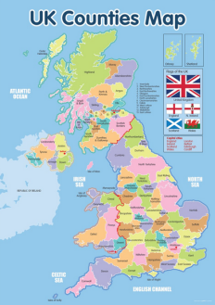 | 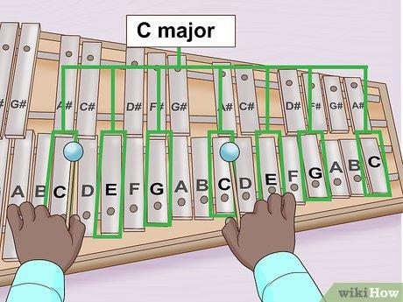 |  | 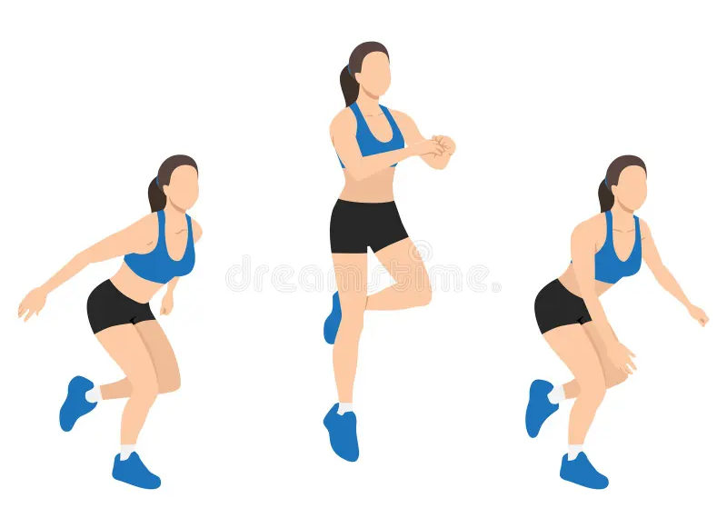 | 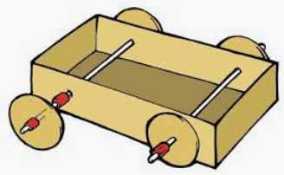 | 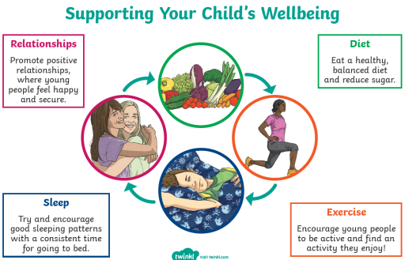
In School: | In School: | In School: | In School: | In School: | In School:
- I can name the four countries of the UK, capital cities and surrounding seas.  - I can use a range of maps (world, country, street maps, aerial views and plans) to locate places and landmarks.  - I can use world maps and globes to begin to locate some continents and countries. | - I can follow a melody accurately when singing.  - I can follow instructions about performing (when to play and sing)  - I can improve my own work when repeating patterns/ ideas when listening to music.  - I can perform with others songs/ simple rhythmic patterns on an instrument. | - I can explain that many people have objects in their home that are ‘precious’ to them and that these can be linked to religion.  - I can recognise objects that can be found in many Jewish homes.  - I can describe what some of the words inside a mezuzah mean.  - I can explain that Jewish people believe in one God  - I can explain why a mezuzah is put on the doorposts of houses.  - I can explain why Jewish people celebrate Shabbat and describe how they welcome Shabbat on a Friday night.  - I can describe how Jewish people both rest and pray at Shabbat.  - I understand the story of (and can describe Jewish practices during) Chanukah.  - I can explain how Jewish practices at Chanukah help Jews to reflect on important aspects of the story. | - I can roll a ball and pick it up as it slows down.  - I can use a simple underarm throw, into space and catch with two hands.  - I can understand why we need to warm up and cool down our bodies.  - I can run or walk forwards, backwards and balance while controlling a ball. | - Try out different axle fixings and their strengths and weaknesses.  - Make vehicles with construction kits which contain free running wheels.  - Use a range of materials to create models with wheels and axles e.g. tubes, dowel, cotton reels. | - I know what is meant by a healthy lifestyle.  - I know how to maintain physical, mental and emotional health and wellbeing.  - I understand ways to keep physically and emotionally safe.
At Home: | At Home: | At Home: | At Home: | At Home: | At Home:
Use a children’s atlas to explore different maps. When the weather is on the TV, show the children where they live. | Listen to music whenever possible and encourage the children to have favourites and to sing along. | Ask your child to find objects that are special to them at home and bring them to school for show and tell. | Take every opportunity for to play outside, visiting the park and the playground in order to get daily exercise and fresh air. Play hop scotch and other footwork games. | Practice cutting, folding and sticking a range of different materials to make a car. Bring it in to show. | Encourage your child to have positive relationships with other, eat healthily, exercise daily and get plenty of sleep.
More detail as to content of the Year 2 Curriculum can be found on the school website.

