Netherton Moss Primary School Year 5 School Curriculum Highlights Autumn Term 1 2024

These are the topics and areas of the school curriculum that the children in Year 5 will be studying this half term. As you can see, there are the key learning intentions (What the children will know and be able to do) for each area and some ideas for ways in which you could help support this learning at home. If you have any further questions about what is going on in our lessons, then please call in at the end of the school day and find out more.

English | Maths | Science | ICT & Computing | Art & Design | Modern Foreign Languages
Talk for Writing | Place Value, Addition and Subtraction | Living Things and their Habitats  Properties and Changes in Materials | Internet Safety & Word Processing | Working in 3 Dimensions  (Set Design) | Spanish  (Talking About Us)
   | 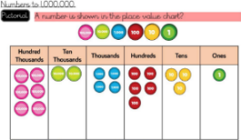 | 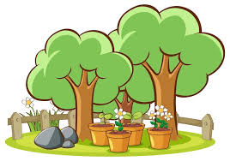  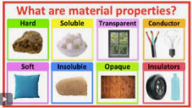 |  | 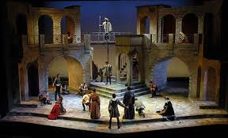 | 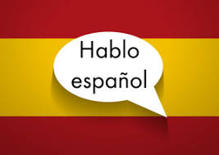
In School: | In School: | In School: | In School: | In School: | In School:
This term our writing focus will be finding tales, setting descriptions and instructions.  We will teach writing by following our whole school Talk for Writing approach. Through fun activities children will learn a model text by heart. They will think about the key features of the text and explore the techniques that the author has used. We follow this with shared writing, to show children how to craft their writing in the same style as our model text. Children will then apply skills learnt during the unit by crafting an independent piece of writing. | In our number and place value unit,  we will learn to read, write, order and compare numbers to 1,000,000. We will count in powers of 10 for any given number up to 1,000,000. We will learn to round any number up to 1,000,000 to the nearest 10, 100, 1,000, 10,000 and 100,00.  In our addition and subtraction unit we will, add and subtract mentally with increasingly large numbers. We will use columnar addition and subtraction to add and subtract whole numbers with more than four digits, We will solve multi-step problems in context and decide which operations and methods to use and why. | Our biology-based unit is living things and their habitats. We will be working in the school science garden, creating a frog habitat, planting bulbs and shrubs for wildlife. We will also explore the school to develop our understanding of the life cycle of trees.  Our chemistry-based unit is materials and their properties. Children will investigate the properties of classroom objects, predicting and measuring transparency, electrical and thermal conductivity and magnetism. We will think about suitable methods to separate different mixtures and explore filtration and evaporation. | Children will learn what a word processing tool is for. They will learn to create a word processing document, altering the look of text and navigating around the document. They will also add  edit images to a document, and use tables within Google Docs to present information | Children will learn about how artists make theatre sets to share ideas. Using WW1 trenches as inspiration, children will be challenged to design and then create a 3D model of a theatre set for a World War 1 theatre/TV production. | Children will continue their learning in Spanish, by asking and answering questions about how they are feeling. They will learn to use because to extend their answers, for example I am happy because it is my birthday. Children will also learn the pronouns for he and she, so that they can describe other people and talk about how they feel as well. They will also learn the vocabulary for different school subjects and will learn how to express their opinions about whether they like or dislike certain subjects.
At Home: | At Home: | At Home: | At Home: | At Home: | At Home:
Read and share stories at home  Practice weekly spellings | Practice weekly calculation sheets  Spend 15 minutes 3 times a week on TT Rock Stars | Have a go at dissolving bath bombs, sugar, salt, flour or soil at home. Which substances dissolve? Can you speed up how fast something dissolves? | Use Google Docs at home to create word documents | Talk about movie sets at home when watching a movie – challenge children to make a 3D model at home using bits and bobs from around the home. | Encourage your child to tell you how they are feeling in Spanish. Ask them about their school subjects and see if they can name the different subjects in Spanish.
History | Music | Religious Education | Physical Education 1 | Physical Education 2 | PSHE
World War One | Clarinets | Why do some people believe that God exists? | Real Gym – Balance and Rotation | Orienteering | Keeping Safe and Being Responsible
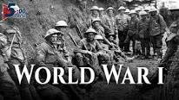 | 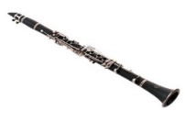 |  | 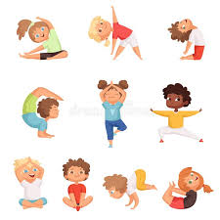 | 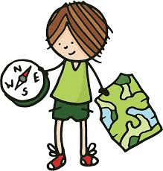 | 
In School: | In School: | In School: | In School: | In School: | In School:
Children will learn where WW1 fits into the chronological framework of world history. They will think about how our knowledge of the past is constructed from a range of historical sources. They will learn about aspects of WW1 that are significant locally, for example the Liverpool PALs King’s Battalion. We will enhance our learning with a visit to two local war memorials and the Liverpool museum. Working as historians, children will address and devise historically-valid questions. They will present their findings after thoughtful selection and organisation of relevant historical information. | Children will learn how to assemble a clarinet correctly so that it is ready to play. They will learn to adopt the correct posture and hand position in order to play successfully. They will begin to achieve the correct embouchure when playing. | Children will be able to explain what the words atheist, theist and agnostic mean. They will be able to describe a Christian’s view of what God is like. They will be supported to talk thoughtfully about the effect of believing or not believing in God may have on someone’s life. | We will use out whole school Real Gym resources to develop gymnastics skills. Children will explore travelling with fluency and control. We will explore creating movement patterns using hand held apparatus, for example, hoops, ribbons and balls. We will also incorporate small apparatus into our routines; walking along a bench, jumping on and off a bench and bunny hopping along a bench. We will work with a partner to create routines that apply the skills that we learn in this unit. | Children will learn to mark control points on a map. They will show that they can accurately find points on a map. They will work as part of a team to complete a task and will navigate with increasing confidence. | In PHSE we will think and talk about talk about the differences between a risky choice and a safe choice. We will think about rules and consider why rules are put in place, and how they can keep us safe if we follow them carefully. We will also explore relationships with our peers and think about and learn how to recognise peer pressure. Children will consider who they can speak to if they are struggling.
At Home: | At Home: | At Home: | At Home: | At Home: | At Home:
Use the internet to find out more about the World War One and share any interesting facts. Visit Liverpool Museum and the Pals memorial in Lime Street Station and learn more about WW1 together. | Listen to music whenever possible and encourage the children to have favourites.  Consider buying a recorder for further practice at home. | Encourage children to talk about what they have been learning in school. |  | Check out geocatching.com. Download the app and use your smart phone to find and navigate to cache near you. Keep your eye out so you can spot the caches camouflaged hiding place. | Encourage children to talk about  their relationships with peers at home. Support children to understand who they can talk to if they are struggling.

