Netherton Moss Primary School
Feedback and Marking Policy
September 2024


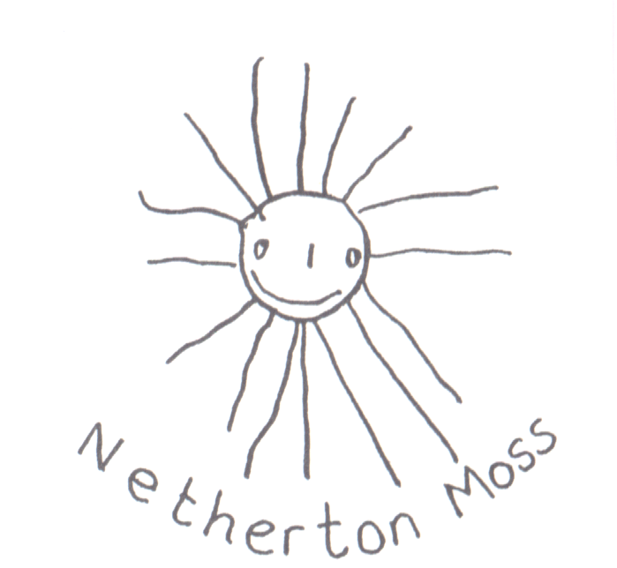

Formative assessment is intended to inform teaching and learning. There is no intrinsic value in recording formative assessment, what matters is that it is acted on
(John McIntosh CBE ‘Final Report of the Commission on Assessment without Levels 2015)

What is the purpose of this policy?
The purpose of this policy is to make explicit how teachers mark children’s learning and provide feedback at Netherton Moss. Marking and feedback are used to promote learning and all members of staff are expected to be familiar with the policy and to apply it consistently.
Why do we need a marking policy?
At Netherton Moss we believe it is important to provide constructive feedback to children, focusing on success and improvement needs against learning objectives. This enables children to become reflective learners and helps them to progress between what they can currently do and what we would like them to be able to do.
What are the principles that guide our school’s approach to marking?
We believe marking and feedback should:
- Be manageable for teachers and accessible, meaningful and motivating to children.
- Recognise that verbal feedback is the most meaningful for children, and enables any misconceptions to be addressed immediately.
- Relate to the learning objective and comment on previous attainment within the context of the learning objective or target
- Involve all adults working with the children in the classroom
- Give recognition and praise for achievement and clear strategies for improvement
- Allow specific time for children to read, reflect and respond to any written marking in order to impact on learning.
- Use a range of methods to give children regular and constructive feedback, this will contribute to their progress and learning over time.
- Respond to individual learning needs & contexts: e.g. feeding back verbally, marking face to face with some and at a distance with others, peer marking and self-evaluation (RAG) as appropriate.
- Inform future planning and group target setting
- Use age and ability appropriate codes across the school that are shared with the children.
- Ultimately be seen by children as a positive approach to improving their learning.
- Marking should provide a model of written, formal English.
- Children’s work needs to be marked in a colour that can be seen. At Netherton Moss all teachers mark in a pen that is a different colour to the children’s work.
- We mark children’s work regularly and we provide feedback (oral and written) to enable children to make progress when appropriate.
Expectations in children’s books
Children’s work should be dated and titled as appropriate to reflect the content and/or learning objective.
Symbols
The following marking symbols will be used:
T - Guided by or supported by Teacher
TA - Guided by or supported by Teaching Assistant
VF - Verbal Feedback
I - Independent
ST-Supply Teacher
The expectation is that there will be evidence of peer and self-assessment in children’s books over time.
In order for the marking to be formative, the information must be used and acted on by the children, therefore, time is planned in for children to respond.
What about correcting spelling, punctuation and grammar?
When children have completed a task, teachers ask them to check for things that they know are wrong in their learning when they read it through. All spelling and punctuation errors will not necessarily be picked up, but will be noted as a future teaching point. This encourages independence and self-editing. We use an agreed age appropriate editing strategy, please see appendix 1.
How do adults in the Foundation Stage mark children’s work?
In the Foundation Stage all adults will focus on giving verbal feedback to the children. In Nursery, the work will be evidenced in children’s learning journeys on the Evidence Me App from 2Simple. In Reception the children have their own paper-based learning journey where evidence is kept if appropriate. Recording is made on the Sefton EYFS Evidence Grids.
How will this policy be monitored?
Leaders have the confidence at Netherton Moss to conduct a professional assessment of children’s work, founded on a strong sense of trust and faith in the judgements made by staff. All teaching staff will be involved in monitoring and sharing children’s books. Formal monitoring will be led by subject leaders, or members of the SLT involving scrutinising books and lesson observations. Lesson observations provide an opportunity to monitor the quality of immediate verbal feedback, which has the highest impact on moving children’s learning forward.
Appendix 1 - KS1 & KS2 Editing Strategies


