Online safety policy

Netherton Moss Primary School
Approved by: Janice Sharp & Laura Walsh Date: 4th February 2020
Last reviewed on: Jan 2016
Next review due by: 2022

Contents
1. Aims 2
2. Legislation and guidance 2
3. Roles and responsibilities 2
4. Educating pupils about online safety 3
5. Educating parents about online safety 4
6. Cyber-bullying 4
7. Acceptable use of the internet in school 5
8. Pupils using mobile devices in school 5
9. Staff using work devices outside school 5
10. How the school will respond to issues of misuse 5
11. Training 6
12. Monitoring arrangements 6
13. Links with other policies 6
Appendix 1: EYFS, KS1 & KS2 acceptable use guidance 7
Appendix 2: Internet, Photographic and Acceptable Use Form for Parents 8
Appendix 3: acceptable use agreement (staff, governors, volunteers and visitors) 9
Appendix 4: online safety training needs – self audit for staff 10

1. Aims
Our school aims to:
- Have robust processes in place to ensure the online safety of pupils, staff, volunteers and governors
- Deliver an effective approach to online safety, which empowers us to protect and educate the whole school community in its use of technology
- Establish clear mechanisms to identify, intervene and escalate an incident, where appropriate

2. Legislation and guidance
This policy is based on the Department for Education’s (DfE) statutory safeguarding guidance, Keeping Children Safe in Education, and its advice for schools on:
- Teaching online safety in schools
- Preventing and tackling bullying and cyber-bullying: advice for headteachers and school staff
- Relationships and sex education
- Searching, screening and confiscation
It also refers to the Department’s guidance on protecting children from radicalisation.
It reflects existing legislation, including but not limited to the Education Act 1996 (as amended), the Education and Inspections Act 2006 and the Equality Act 2010. In addition, it reflects the Education Act 2011, which has given teachers stronger powers to tackle cyber-bullying by, if necessary, searching for and deleting inappropriate images or files on pupils’ electronic devices where they believe there is a ‘good reason’ to do so.
The policy also takes into account the National Curriculum computing programmes of study.

3. Roles and responsibilities
3.1 The governing board
The governing board has overall responsibility for monitoring this policy and holding the headteacher to account for its implementation.
The governing board will co-ordinate regular meetings with appropriate staff to discuss online safety, and monitor online safety logs as provided by the designated safeguarding lead (DSL).
All governors will:
- Ensure that they have read and understand this policy
- Agree and adhere to the terms on acceptable use of the school’s ICT systems and the internet (appendix 3)
3.2 The headteacher
The headteacher is responsible for ensuring that staff understand this policy, and that it is being implemented consistently throughout the school.
3.3 The designated safeguarding lead
Details of the school’s DSL and deputy/deputies are set out in our child protection and safeguarding policy as well relevant job descriptions.
The DSL takes lead responsibility for online safety in school, in particular:
- Supporting the headteacher in ensuring that staff understand this policy and that it is being implemented consistently throughout the school
- Working with the headteacher, ICT manager and other staff, as necessary, to address any online safety issues or incidents
- Ensuring that any online safety incidents are logged (CPOMs) and dealt with appropriately in line with this policy
- Ensuring that any incidents of cyber-bullying are logged and dealt with appropriately in line with the school behaviour policy (CPOMs)
- Updating and delivering staff training on online safety (appendix 4 contains a self-audit for staff on online safety training needs)
- Liaising with other agencies and/or external services if necessary
3.4 The ICT manager
The ICT manager is responsible for:
- Putting in place appropriate filtering and monitoring systems, which are updated on a regular basis and keep pupils safe from potentially harmful and inappropriate content and contact online while at school, including terrorist and extremist material
- Ensuring that the school’s ICT systems are secure and protected against viruses and malware, and that such safety mechanisms are updated regularly
- Ensure full security check and monitoring the school’s ICT systems are completed on a regular basis.
- Blocking access to potentially dangerous sites and, where possible, preventing the downloading of potentially dangerous files
- Ensuring that any online safety incidents are logged and dealt with appropriately in line with this policy
- Ensuring that any incidents of cyber-bullying are dealt with appropriately in line with the school behaviour policy
3.5 All staff and volunteers
All staff, including contractors and agency staff, and volunteers are responsible for:
- Maintaining an understanding of this policy
- Implementing this policy consistently
- Agreeing and adhering to the terms on acceptable use of the school’s ICT systems and the internet (appendix 3), and ensuring that pupils follow the school’s terms on acceptable use through general monitoring and teaching in class (appendix 1)
- Working with the DSL to ensure that any online safety incidents are logged (see appendix 5) and dealt with appropriately in line with this policy
- Ensuring that any incidents of cyber-bullying are dealt with appropriately in line with the school behaviour policy
This list is not intended to be exhaustive.
3.6 Parents
Parents are expected to:
- Notify a member of staff or the headteacher of any concerns or queries regarding this policy
- Ensure they have read, understood and agreed to the terms on acceptable use of the school’s ICT systems and internet (appendix 2)
Parents can seek further guidance on keeping children safe online from the following organisations and websites:
- What are the issues? - UK Safer Internet Centre
- Hot topics - Childnet International
- Parent factsheet - Childnet International
3.7 Visitors and members of the community
Visitors and members of the community who use the school’s ICT systems or internet will be made aware of this policy, when relevant, and expected to read and follow it. If appropriate, they will be expected to agree to the terms on acceptable use (appendix 3).

4. Educating pupils about online safety
Pupils will be taught about online safety as part of the curriculum:
In Key Stage 1, pupils will be taught to:
- Use technology safely and respectfully, keeping personal information private
- Identify where to go for help and support when they have concerns about content or contact on the internet or other online technologies
Pupils in Key Stage 2 will be taught to:
- Use technology safely, respectfully and responsibly
- Recognise acceptable and unacceptable behaviour
- Identify a range of ways to report concerns about content and contact
By the end of primary school, pupils will know:
- That people sometimes behave differently online, including by pretending to be someone they are not.
- That the same principles apply to online relationships as to face-to-face relationships, including the importance of respect for others online including when we are anonymous
- The rules and principles for keeping safe online, how to recognise risks, harmful content and contact, and how to report them
- How to critically consider their online friendships and sources of information including awareness of the risks associated with people they have never met
- How information and data is shared and used online
- How to respond safely and appropriately to adults they may encounter (in all contexts, including online) whom they do not know
The safe use of social media and the internet will also be covered in other subjects where relevant.
The school will use assemblies to raise pupils’ awareness of the dangers that can be encountered online and may also invite speakers to talk to pupils about this.

5. Educating parents about online safety
The school will raise parents’ awareness of internet safety in letters or other communications home, and in information via our website. This policy will also be shared with parents.
Online safety will also be covered during parents’ evenings.
If parents have any queries or concerns in relation to online safety, these should be raised in the first instance with the headteacher and/or the DSL.
Concerns or queries about this policy can be raised with any member of staff or the headteacher.

6. Cyber-bullying
6.1 Definition
Cyber-bullying takes place online, such as through social networking sites, messaging apps or gaming sites. Like other forms of bullying, it is the repetitive, intentional harming of one person or group by another person or group, where the relationship involves an imbalance of power. (See also the school behaviour policy.)
6.2 Preventing and addressing cyber-bullying
To help prevent cyber-bullying, we will ensure that pupils understand what it is and what to do if they become aware of it happening to them or others. We will ensure that pupils know how they can report any incidents and are encouraged to do so, including where they are a witness rather than the victim.
The school will actively discuss cyber-bullying with pupils, explaining the reasons why it occurs, the forms it may take and what the consequences can be. Teaching staff are also encouraged to find opportunities to use aspects of the curriculum to cover cyber-bullying. This includes personal, social, health and economic (PSHE) education, and other subjects where appropriate.
All staff, governors and volunteers (where appropriate) receive training on cyber-bullying, its impact and ways to support pupils, as part of safeguarding training.
The school also sends information/leaflets on cyber-bullying to parents so that they are aware of the signs, how to report it and how they can support children who may be affected.
In relation to a specific incident of cyber-bullying, the school will follow the processes set out in the school behaviour policy. Where illegal, inappropriate or harmful material has been spread among pupils, the school will use all reasonable endeavours to ensure the incident is contained.
The DSL will consider whether the incident should be reported to the police if it involves illegal material, and will work with external services if it is deemed necessary to do so.
6.3 Examining electronic devices
School staff have the specific power under the Education and Inspections Act 2006 (which has been increased by the Education Act 2011) to search for and, if necessary, delete inappropriate images or files on pupils’ electronic devices, including mobile phones, iPads and other tablet devices, where they believe there is a ‘good reason’ to do so.
When deciding whether there is a good reason to examine or erase data or files on an electronic device, staff must reasonably suspect that the data or file in question has been, or could be, used to:
- Cause harm, and/or
- Disrupt teaching, and/or
- Break any of the school rules
If inappropriate material is found on the device, it is up to the staff member in conjunction with the DSL or other member of the senior leadership team to decide whether they should:
- Delete that material, or
- Retain it as evidence (of a criminal offence or a breach of school discipline), and/or
- Report it to the police
Any searching of pupils will be carried out in line with the DfE’s latest guidance on screening, searching and confiscation.
Any complaints about searching for or deleting inappropriate images or files on pupils’ electronic devices will be dealt with through the school complaints procedure.

7. Acceptable use of the internet in school
All parents, staff and governors are expected to sign an agreement regarding the acceptable use of the school’s ICT systems and the internet (appendix 3). Visitors will be expected to read and agree to the school’s terms on acceptable use if relevant.
Use of the school’s internet must be for educational purposes only, or for the purpose of fulfilling the duties of an individual’s role.
We will monitor the websites visited by pupils, staff, volunteers, governors and visitors (where relevant) to ensure they comply with the above.
More information is set out in the acceptable use agreements in appendices 1, 2 and 3.

8. Pupils using mobile devices in school
We understand that many parents request their older children (i.e. UKS2) have their mobile phones brought into school – particularly as they walk home on their own and may need to contact each other; however, the use of phones are not encouraged in school and will be collected and safely stored ready for pupils to collect at home time.
Any breach of the acceptable use agreement by a pupil may trigger disciplinary action in line with the school behaviour policy, which may result in the confiscation of their device.

9. Staff using work devices outside school
Staff members using a work device outside school must not install any inappropriate software on the device and must not use the device in any way which would violate the school’s terms of acceptable use, as set out in appendix 3.
Staff must ensure that their work device is secure and password-protected, and that they do not share their password with others. They must take all reasonable steps to ensure the security of their work device when using it outside school. Any USB devices containing data relating to the school must be encrypted.
If staff have any concerns over the security of their device, they must seek advice from the ICT manager.

10. How the school will respond to issues of misuse
Where a pupil misuses the school’s ICT systems or internet, we will follow the procedures set out in our policies on behaviour and ICT and internet acceptable use. The action taken will depend on the individual circumstances, nature and seriousness of the specific incident, and will be proportionate.
Where a staff member misuses the school’s ICT systems or the internet, or misuses a personal device where the action constitutes misconduct, the matter will be dealt with in accordance with the staff disciplinary procedures/staff code of conduct. The action taken will depend on the individual circumstances, nature and seriousness of the specific incident.
The school will consider whether incidents which involve illegal activity or content, or otherwise serious incidents, should be reported to the police.

11. Training
All new staff members will receive training, as part of their induction, on safe internet use and online safeguarding issues including cyber-bullying and the risks of online radicalisation.
All staff members will receive refresher training at least once each academic year as part of safeguarding training, as well as relevant updates as required (for example through emails, e-bulletins and staff meetings).
The DSL and deputy/deputies will undertake child protection and safeguarding training, which will include online safety, at least every 2 years. They will also update their knowledge and skills on the subject of online safety at regular intervals, and at least annually.
Governors will be updated training on safe internet use and online safeguarding issues as part of their safeguarding training.
Volunteers will receive appropriate training and updates, if applicable.

12. Monitoring arrangements
Any incidents will be reported and can be found on CPOMS, which the school uses for Child Safety.
This policy will be reviewed every 3 years by the ICT/Computing Leader. At every review, the policy will be shared with the governing board.

13. Links with other policies
This online safety policy is linked to our:
- Child protection and safeguarding policy
- Behaviour policy
- Staff disciplinary procedures
- Data protection policy and privacy notices
- Complaints procedure
- ICT and internet acceptable use policy

Appendix 1: EYFS, KS1 & KS2 acceptable use guidance
Acceptable use of the school’s ICT systems and internet: agreement for pupils and parents/carers
Name of pupil:
When I use the school’s ICT systems (like computers) and get onto the internet in school I will:
- Ask a teacher or adult if I can do so before using them
- Always use the school’s ICT systems and the internet responsibly and for educational purposes only
- Only use websites that a teacher or adult has told me or allowed me to use
- Tell my teacher immediately if:
  - I click on a website by mistake
  - I receive messages from people I don’t know
  - I find anything that may upset or harm me or my friends
- Use school computers for school work only
- I will be kind to others and not upset or be rude to them
- Look after the school ICT equipment and tell a teacher straight away if something is broken or not working properly
- Only use the username and password I have been given
- Never share my password with anyone, including my friends.
- Never give my personal information (my name, address or telephone numbers) to anyone without the permission of my teacher or parent/carer
- Save my work on the school network
- Check with my teacher before I print anything
- Log off or shut down a computer when I have finished using it
I agree that the school will monitor the websites I visit and that there will be consequences if I don’t follow the rules.
I will not:
- Access any inappropriate websites including: social networking sites, chat rooms and gaming sites unless my teacher has expressly allowed this as part of a learning activity
- Open any attachments in emails, or follow any links in emails, without first checking with a teacher
- Use any inappropriate language when communicating online, including in emails
- Log in to the school’s network using someone else’s details
- Arrange to meet anyone offline without first consulting my parent/carer, or without adult supervision
If I bring a personal mobile phone or other personal electronic device into school:
- I will not use it during school time.
- I will hand it in to my teacher and I accept it will be locked safely away until I need to go home.
I agree that the school will monitor the websites I visit and that there will be consequences if I don’t follow the rules.

Appendix 2: Internet, Photographic and Acceptable Use Form for Parents

Internet, Photographic and Acceptable Use Form for Parents and Carers
Name of parent/carer:
Name of child: Child’s Class:
As your child progresses through the school s/he will use the internet in more varied and challenging ways.
Your child will be trained in the acceptable use of all hardware and software connected with ICT, including behaviour on the internet. Children will be taught, among other things…
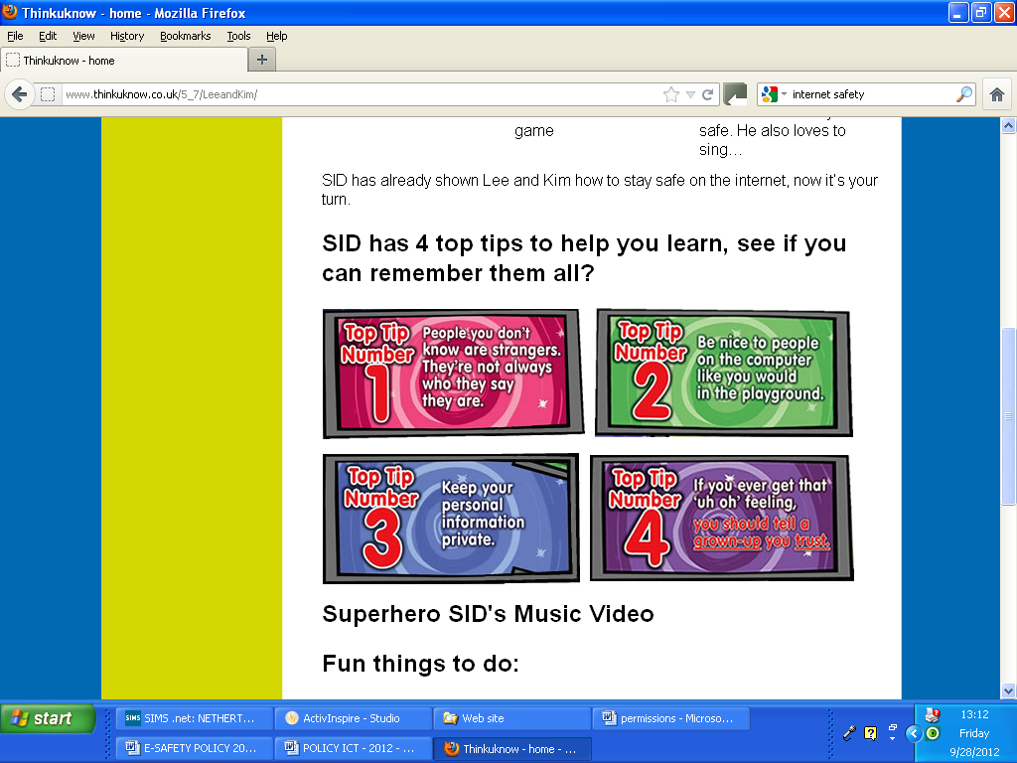

http://www.thinkuknow.co.uk/5_7/ and http://www.thinkuknow.co.uk/8_10/
- The children will access many sites through the use of passwords and user names; please encourage them to keep them safe and not to share personal details with others.
- We need Parents and Guardians to agree that they will encourage their children to behave well at home on the internet and that parents will lead by example through the appropriate use of the internet and social networking sites, such as Facebook, Twitter, Instagram etc.
- We encourage you to be positive in any comments made about children’s work and the schools on whatever site you interact with and we hope you will use the school’s website for updates on all that is happening in Netherton Moss.
- I understand that photographs and videos may be taken by the school for the purposes of recording pupil’s activities and attainment. I understand that this will be done sensitively and in a manner that is for internal use only.
Signed: | Date:
Please fill in ALL sections | Please Circle
1a. I agrees that you may use an unidentified picture of my child in a school booklet or display to promote the school. | Yes / No
1b. I agree that you may use an unidentified pictures of my child on the school’s website, which is accessible to the public | Yes / No
1c. I agree that my child may appear in a video presentation made by, or authorised by the school | Yes / No
2a. I agree that my child may be photographed, interviewed or filmed by outside organisations such as the press, radio or television if permission is granted to those organisations by the Headteacher. | Yes / No
2b. I agree that my child’s name may be provided to outside organisations as mentioned above for the possible publication with a photograph or film, given that the above considerations with regard to appropriate use have been made.. | Yes / No

Appendix 3: acceptable use agreement (staff, governors, volunteers and visitors)
Acceptable use of the school’s ICT systems and internet: agreement for staff, governors,volunteers and visitors
Name of staff member/governor/volunteer/visitor:
When using the school’s ICT systems and accessing the internet in school, or outside school on a work device (if applicable), I will not:
- Access, or attempt to access inappropriate material, including but not limited to material of a violent, criminal or pornographic nature (or create, share, link to or send such material)
- Use them in any way which could harm the school’s reputation
- Access social networking sites or chat rooms
- Use any improper language when communicating online, including in emails or other messaging services
- Install any unauthorised software, or connect unauthorised hardware or devices to the school’s network
- Share my password with others or log in to the school’s network using someone else’s details
- Take photographs of pupils without checking with teachers first
- Share confidential information about the school, its pupils or staff, or other members of the community
- Access, modify or share data I’m not authorised to access, modify or share
- Promote private businesses, unless that business is directly related to the school
I will only use the school’s ICT systems and access the internet in school, or outside school on a work device, for educational purposes or for the purpose of fulfilling the duties of my role.
I agree that the school will monitor the websites I visit and my use of the school’s ICT facilities and systems.
I will take all reasonable steps to ensure that work devices are secure and password-protected when using them outside school, and keep all data securely stored in accordance with this policy and the school’s data protection policy.
I will let the designated safeguarding lead (DSL) and ICT manager know if a pupil informs me they have found any material which might upset, distress or harm them or others, and will also do so if I encounter any such material.
I will always use the school’s ICT systems and internet responsibly, and ensure that pupils in my care do so too.
Signed (staff member/governor/volunteer/visitor): | Date:

Appendix 4: online safety training needs – self audit for staff
online safety training needs audit
Name of staff member/volunteer: | Date:
Question | Yes/No (add comments if necessary)
Do you know the name of the person who has lead responsibility for online safety in school?
Do you know what you must do if a pupil approaches you with a concern or issue?
Are you familiar with the school’s acceptable use agreement for staff, volunteers, governors and visitors?
Are you familiar with the school’s acceptable use agreement for pupils and parents?
Do you regularly change your password for accessing the school’s ICT systems?
Are you familiar with the school’s approach to tackling cyber-bullying?
Are there any areas of online safety in which you would like training/further training?

