
Intimate Care Policy

At Netherton Moss we are committed to safeguarding and promoting the welfare of children and young people.
• We are committed to ensuring that all staff responsible for intimate care of children and young people will undertake their duties in a professional manner at all times.
• We are committed to ensuring that children are treated with sensitivity and respect.

What is ‘Intimate care’
Intimate care is defined as any care which involves washing, touching or carrying out an invasive procedure that most children and young people carry out for themselves, but which some are too young to or are unable to do. Intimate care tasks are associated with bodily functions, body products and personal hygiene that demands direct or indirect contact with, or contact with intimate personal areas. Examples include support with dressing and undressing (underwear), changing incontinence pads and nappies, helping someone use the toilet or washing intimate parts of the body, cleaning a pupil who has soiled him/herself or vomited. It is also associated with other accidents that may require a child to remove their clothes. These include changes required as a result of water play, messy play, sickness and weather. Very young or disabled pupils may be unable to meet their own care needs for a variety of reasons and will require regular support.

Practicalities
It is generally expected that most children will be toilet trained and out of nappies before they begin at school or nursery. However, we recognise that children will join Netherton Moss, having reached differing levels of independence and development in toileting and self-care. Therefore, it is inevitable that from time to time some children will have accidents and need to be attended to. In order to help the children to become aware of their bodily needs and respond to them in time, those who wish to go to the toilet are always allowed to go. Although they are encouraged as they progress through the school to use the toilet during break times.
Children in the EYFS have access to the toilet whenever they need to and are encouraged to be as independent as is age and developmentally appropriate. They are reminded at regular times to go to the toilet and are also encouraged to wash their hands after the toilet.

Child Protection
Child Protection procedures will be adhered to at all times. All the staff in school hold an Enhanced Criminal Record Bureau disclosure. Any staff awaiting their disclosure are not to be left alone unsupervised with pupils until this is received. Staff also hold appropriate qualifications, references and skills. Students and volunteers will not provide intimate care for pupils. If a child makes an allegation about a member of staff, this will be investigated in accordance with agreed procedures.

AGREED PROCEDURES
1.On occasions when a pupil may need to be changed it will be done by a known member of staff who will be
sensitive to their needs i.e. talk about what they are doing, be gentle and consider their feelings.
2. All pupils will be encouraged to use the self-care skills that are appropriate for their age e.g. removing
clothing, wiping themselves etc.
3. When necessary pupils will be taken to the toilet in the EYFS unit or the Nurses Office. Wipes, bags and spare clothes are stored in the EYFS unit.
4. Staff must always wear gloves when changing pupils and dispose of them appropriately afterwards
5. If the changing unit is used then it must be cleaned down with antibacterial spray afterwards
6. Any member of staff changing a pupil should ensure that another colleague is informed.
7. It is the responsibility of the class teacher to ensure that parents/carers are informed and it is their
decision as to whether it is necessary to telephone the parent or speak to them at the end of the session
8. The intimate care record sheet must be completed. The sheet gives information about the name of the
pupil, date, time, who changed the pupil and the reason for changing them. If any member of staff has a
concern with regards to safeguarding whilst changing a pupil they should inform the designated teacher
and follow the Safeguarding Policy. Staff must also be aware of their own personal safety whilst changing pupils and not put themselves in a vulnerable position.
9. A Toilet Management Plan must be completed with any child who is not toilet-trained.

Role of parents
Parents should give permission for intimate care as children enter Early Years Foundation Stage (EYFS). The permission slips are kept on record. All staff are informed of those children where no permission is given. Where a child has continuing incontinence problems (including children beyond EYFS), parents are expected to provide a complete set of spare clothes and baby-wipes.

INTIMATE CARE POLICY
RECORD SHEET
Please complete each time a child needs to be changed Pupil Name, Date, Time, Person who changed the child, Reason for changing child.
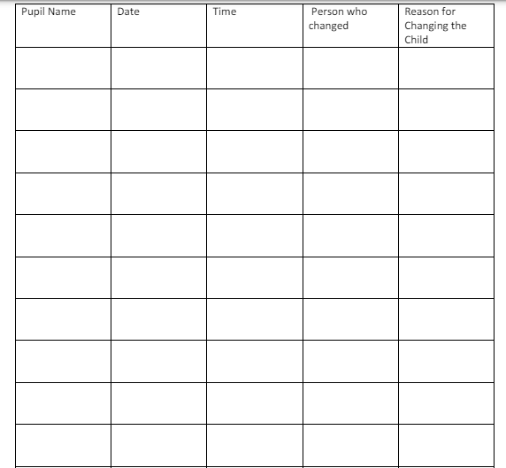

TOILET MANAGEMENT PLAN
Child’s Name: DOB :
Name of Staff Involved
Main points from discussion with parent:

Equipment required:

Support required /Frequency of support:

Working towards Independence

Review Date:
Parent………………………………………………………………………………………………………….. Date …………….
Staff…………………………………………………………………………………………………………… Date …………….



