
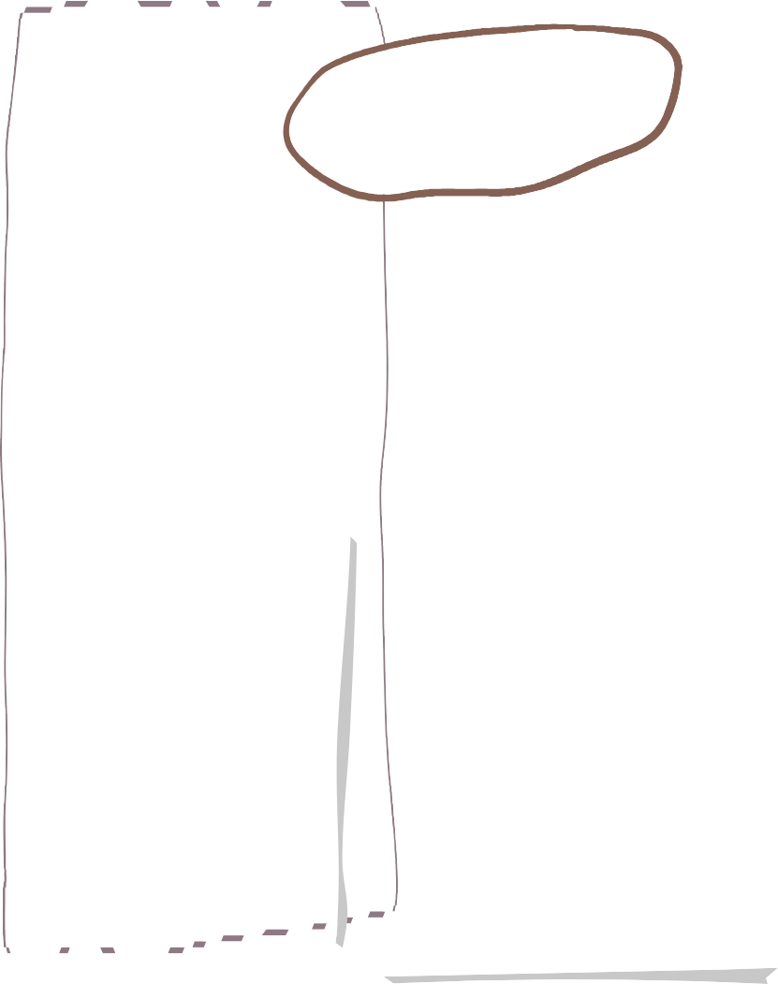






Autumn One in Willow Class
Maths
Science

English
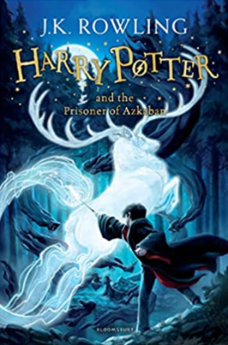
We are reading…
We will be studying ‘ Bill’s New Frock’ this term and using a range of speaking, listening and writing activities centred around the theme of gender stereotypes.

We will also be practicing our spelling, punctuation and grammar work.

As well as encouraging a love for reading within our classroom.
We practice our four calculation and methods and continue to work on our times tables daily.

Our power maths topic this term is Place Value.
Sound
We will identify how sounds are made, associating them something vibrating, recognise how sound travels, find patterns between the volume and pitch of a sound through experiments and theory lessons. Unfair


We will be learning about
Hinduism.
- Suggesting a range of forms of religious expression.
- - We will be able to describe what influences ourselves and others
RE
Drawing and Painting.
By the end of this term we will develop our skills making marks and lines with a wide range of drawing implements e.g. charcoal, pencil , crayon , chalk , pastels and pens.

We will build on our specific colour language
And be able to mix colours and know which primary
Colours make secondary colours.

Art
Homework!

Homework will be set via Class Dojo! If you need help gaining access please speak to a member of the Willow Class team !




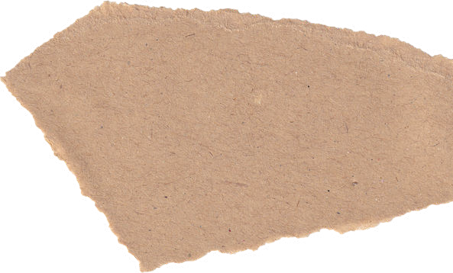


Music
DT
Geography
Our DT topic this term is Healthy Eating (Linking to our science topic).
We will develop sensory vocabulary/knowledge using, smell, taste, texture and feel as well as being able to analyse the taste , texture, smell and appearance of a range of foods.
We will showcase how we can follow instructions/recipes and join/combine a range of ingredients.
We will be learning how to play the recorder.
Getting to grips with the continents and oceans as well as being able to locate countries in the UK, Europe and across the world using maps, atlases, globes and digital/computer software.

Spanish

- We will learn greetings/ and days/weeks/months.

PE
Computing
PE will be every Tuesday and we will be swimming every Wednesday until after Christmas.

In PE we will be learning the skills of Hocky.
- To be able to change speed and direction easily.
- To be able to travel with an object
We will be:
- Continuing to understand how we can be safe online.
- Becoming software developers by using procedures to simplify a program, testing our programme, recognising errors and algorithms.
Focusing on our school expectations and staying safe.
PSHE

