
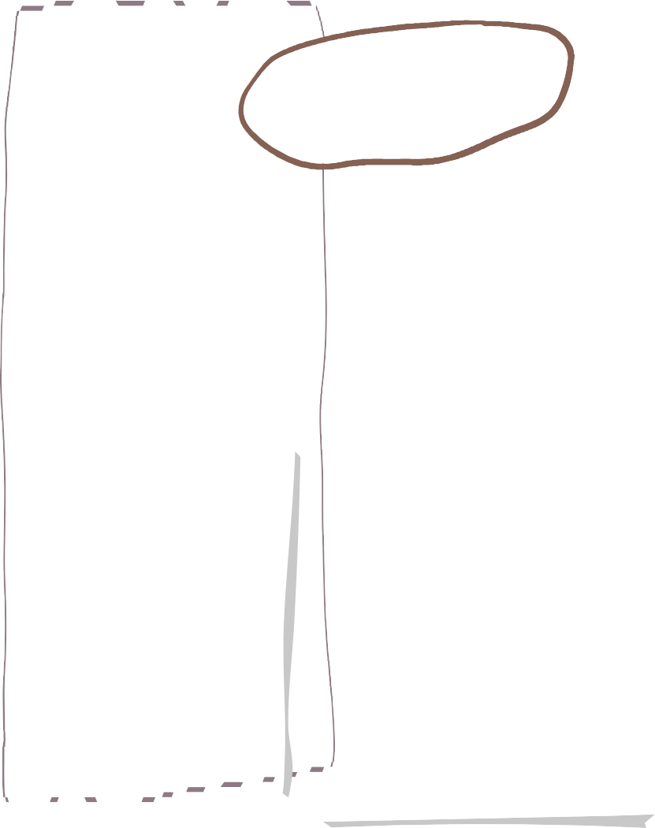






Autumn Two in Willow Class
Maths
Science

English
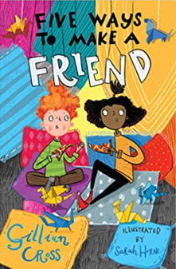
We are reading…
We will be studying ‘ The Lion, The Witch and The Wardrobe this term, taking part in sensory lessons to help support our descriptive writing.

We will also be practicing our spelling, punctuation and grammar work.

As well as encouraging a love for reading within our classroom.
Animal Including Humans (Teeth & Digestion)
• I can describe the simple functions of the basic parts of the digestive system in humans • I can identify the different types of teeth in humans and their simple functions • I can construct and interpret a variety of food chains, identifying producers, predators and prey

We practice our four calculation and methods and continue to work on our times tables daily.
Our power maths topic this term is Place Value and Addition and subtraction..


Christianity
• I can raise and suggest answers to, questions of identity, belonging, meaning, purpose, truth, values and commitments.

RE
Drawing and Painting.
By the end of this term we will develop our skills making marks and lines with a wide range of drawing implements e.g. charcoal, pencil , crayon , chalk , pastels and pens.

We will build on our specific colour language
And be able to mix colours and know which primary
Colours make secondary colours.

Art
Homework!

Homework will be set via Class Dojo! If you need help gaining access please speak to a member of the Willow Class team !







Music
DT
Geography
DT Week Cont.

Product title – To create a greetings card with moving parts for family or friends. Last week we designed, made and evaluated our greetings cards. This term we will uses the skills we have learned to help us design and make Christmas cards.

We will be learning how to play the recorder.
Hemispheres
I can identify the position and significance of latitude, longitude, Equator, Northern Hemisphere, Southern Hemisphere, the Tropics of Cancer and Capricorn, Arctic and Antarctic Circle, the Prime/Greenwich Meridian and time zones (including day and night).

• Physical geography, I can include: climate zones, biomes and vegetation belts

Spanish

- We will learn greetings/ and days/weeks/months.

Forest School Fridays±
We will have forest school sessions on Friday mornings this term starting Nov 11th.

PE
Computing
PE will be every Tuesday and we will be swimming every Wednesday until after Christmas.
Dance/ Movement
I can create movement using a stimulus. • I can explore and improvise ideas for dances in different styles, working on their own, with a partner and in a group. • I can create and link dance phrases using a simple dance structure or motif.

We will be:
- Continuing to understand how we can be safe online.
- Cracking Codes
I recognise that using algorithms will also help solve problems. I can use a variety of tools to create a program.

LFC Foundation PL Primary Stars will be joining us for PSHE sessions based around self-esteem, resilience, and team values.
PSHE

