







Spring 1 in Willow Class
Maths
Science

English
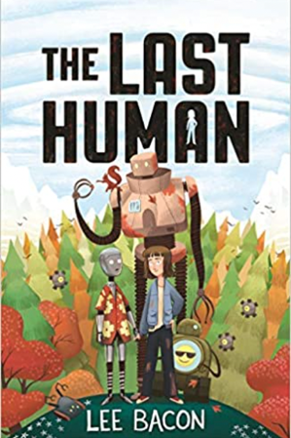
We are reading…
After our informative INSET days we will be introducing Talk 4 Writing in Year 4.

We will also be practicing our spelling, punctuation and grammar work.

As well as encouraging a love for reading within our classroom.
Materials and their properties
I can compare and group materials together, according to whether they are solids, liquids or gases
• I can observe that some materials change state when they are heated or cooled, and measure or research the temperature at which this happens in degrees Celsius (°C)
• I can identify the part played by evaporation and condensation in the water cycle and associate the rate of evaporation with temperature

We practice our four calculation and methods and continue to work on our times tables daily.
Our power maths topic this term is Addition, subtraction and multiplication and division.


Judaism
I can answer the questions: Do you think that we need to have celebrations of key events? Why do you think people have celebrations in different religions?
• I can look at and discuss the significance of

RE
Digital Media
Use a graphics package to create images and effects with; lines by controlling the brush tool with increased precision.
• Create shapes by making selections to cut, duplicate and repeat.
• Experiment with colours and textures by using effects and simple filters to manipulate and create images for a purpose.
• Change the type of brush to an appropriate style.

Art
Homework!

Homework will be set via Class Dojo! If you need help gaining access please speak to a member of the Willow Class team !







Music
DT
Topic
Healthy Eating
I can develop sensory vocabulary/knowledge using, smell, taste, texture and feel.
• I can analyse the taste, texture, smell and appearance of a range of foods (predominantly savoury).
• I can follow instructions/recipes.
• I can make healthy eating choices – use the Eatwell plate.
• I can join and combine a range of ingredients.

We will be learning how to play the recorder.
The Roman Empire and its impact on Britain
By the end of the topic your child will be able to say ….
I have knowledge of Julius Caesar’s attempted invasion in 55-54 BC and the reasons it failed .I understand the power and size of the Roman Empire by AD 42 and the power of its army. I have knowledge of the successful invasion by Claudius and conquest of Britain, including the construction of Hadrian’s Wall I can give examples of British resistance to the Roman Invasion, e.g. Boudica I can explain and give examples of the “Romanisation” of Britain: culture and beliefs. I can use specialist terms like settlement, invasion and vocabulary linked to chronology. \ I have an understanding some significant aspects of history – nature of ancient civilisations; expansion of empires; characteristic features of non-European societies; achievements and follies of mankind.

Spanish

- We will be learning about colours and the body.

PE
Computing
PE – Tuesday & Wednesdays
Tuesdays – Gymnastics
I can focus on developing quality of travelling actions both on feet and hands and feet.
• I can explore a range of symmetrical and asymmetrical actions.

I can focus on developing balances on 1,2,3 or 4 points and large body parts.
• I can focus on developing quality in all the different rolling actions from KS1.

Wednesday - Yoga

We will be:
Continuing to understand how we can be safe online.
Cracking Codes
I recognise that using algorithms will also help solve problems. I can use a variety of tools to create a program.

LFC Foundation PL Primary Stars will be joining us for PSHE sessions based around self-esteem, resilience, and team values.
PSHE

