







Spring 2 in Willow Class
Maths
Science

English
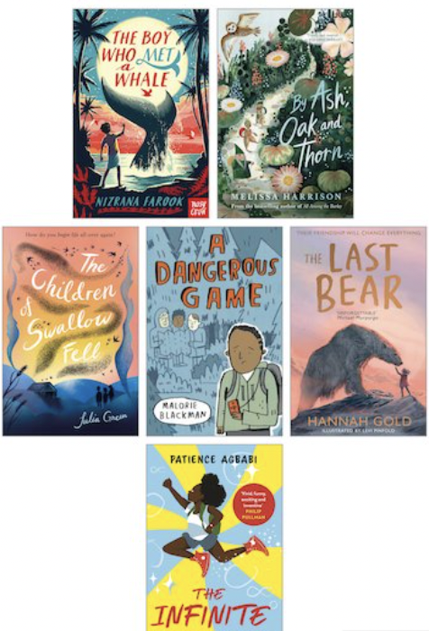
We are reading…
We will be continuing our work using Talk for Writing and this term we will be focusing on Fairy Tales.

We will also be focusing on our SPaG skills throughout this term.
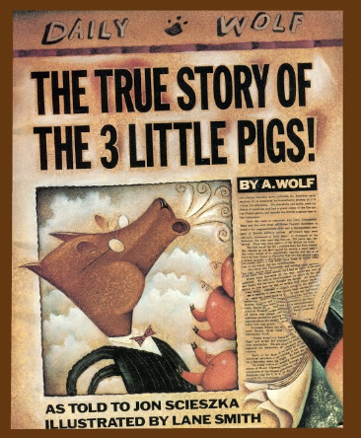.
Materials and their properties
I can compare and group materials together, according to whether they are solids, liquids or gases
• I can observe that some materials change state when they are heated or cooled, and measure or research the temperature at which this happens in degrees Celsius (°C)
• I can identify the part played by evaporation and condensation in the water cycle and associate the rate of evaporation with temperature

We practice our four calculation and methods and continue to work on our times tables daily.
Our power maths topic this term is measurement and multiplication.


Why do believers often see life as a journey and what significant experiences mark this?

RE
Digital Media
Use a graphics package to create images and effects with; lines by controlling the brush tool with increased precision.
• Create shapes by making selections to cut, duplicate and repeat.
• Experiment with colours and textures by using effects and simple filters to manipulate and create images for a purpose.
• Change the type of brush to an appropriate style.

Art
Children will be reading for pleasure throughout the school day as well as listening to a range of high quality texts during class read. We will be developing out fluency, pace and stamina.

In guided reading we will develop our retrieval and inference skills.

Children should be aiming to read daily at home.







Music
DT/PSHE
Topic
Healthy Eating
I can develop sensory vocabulary/knowledge using, smell, taste, texture and feel.
• I can analyse the taste, texture, smell and appearance of a range of foods (predominantly savoury).
• I can follow instructions/recipes.
• I can make healthy eating choices – use the Eatwell plate.
• I can join and combine a range of ingredients.

Royal Philharmonic Orchestra Scheme.
The Roman Empire and its impact on Britain
By the end of the topic your child will be able to say ….
I have knowledge of Julius Caesar’s attempted invasion in 55-54 BC and the reasons it failed .I understand the power and size of the Roman Empire by AD 42 and the power of its army. I have knowledge of the successful invasion by Claudius and conquest of Britain, including the construction of Hadrian’s Wall I can give examples of British resistance to the Roman Invasion, e.g. Boudica I can explain and give examples of the “Romanisation” of Britain: culture and beliefs. I can use specialist terms like settlement, invasion and vocabulary linked to chronology. \ I have an understanding some significant aspects of history – nature of ancient civilisations; expansion of empires; characteristic features of non-European societies; achievements and follies of mankind.

Spanish

- We will be learning about colours and the body.

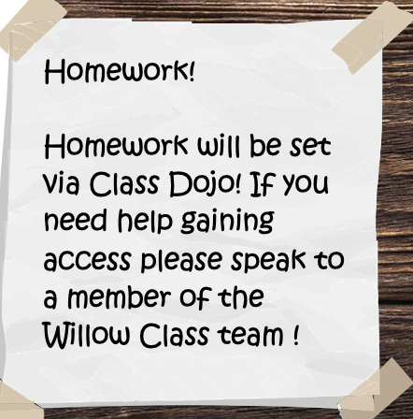

PE
Computing
PE – Tuesday
Tuesdays – Gymnastics
I can focus on developing quality of travelling actions both on feet and hands and feet.
• I can explore a range of symmetrical and asymmetrical actions.

I can focus on developing balances on 1,2,3 or 4 points and large body parts.
• I can focus on developing quality in all the different rolling actions from KS1.

We will be:
Continuing to understand how we can be safe online.
Real World Problem solving.
We will design and create content , explore the use of graphics and paint packages to design and plan an idea as well as, using and combining internet services such as those that provide images, sounds, 3D representations and graphic software.

Pop project- 20th February
Art Exhibition, Willow Class visit the NAC. – 22nd February
Pantomime Visit Netherton Moss – 1st March
World Book Day- Fairy Tale Themed – 2nd March.
Philharmonic Trip -14th March
Romans Day - 22nd March
Events

