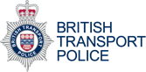

61016: our non-emergency text number
You can text us on 61016 to tell us about non-emergency incidents. In an emergency always dial 999.
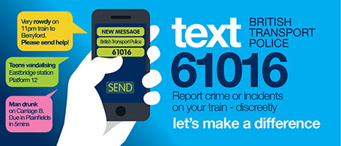
You can text us on 61016 to report non-emergency incidents, similar to the ones you would report to the 101 phone number provided by your local police force.
The text number is monitored 24/7 and, while it is not for reporting emergencies, we will be able to send officers if required.


When to use the text service:
Text 61016 (or call 0800 40 50 40) when you want to contact us about an issue that doesn't require an emergency response. For example, you can text when:
- You want to tell about an incident that has already happened
- You want to tell us about issues affecting your rail journey or your local station
- You have a general police enquiry
If your enquiry concerns buses or roads, you can contact local police anywhere in the country by dialling 101.
Reporting a Sexual Offence

When to call 999:
Always dial 999 when you need an urgent police response such as:
- A crime is happening
- Someone suspected of a crime is nearby
- Someone is injured, being threatened or in danger
Your mobile service provider may issue a small charge to text 61016. The exact cost will depend on your network and tariff.
Advice on when to call 999

Text 61016 - FAQs
Our Q&A gives all the answers on using our text message service.

Contact Us
To report a crime or incident, call
0800 40 50 40
or text 61016
In an emergency call 999

