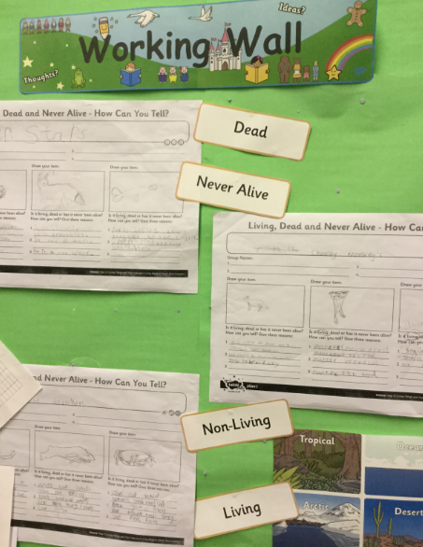
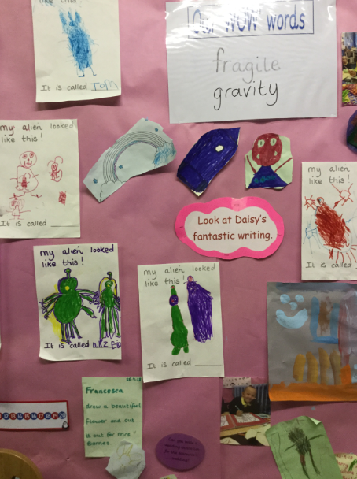
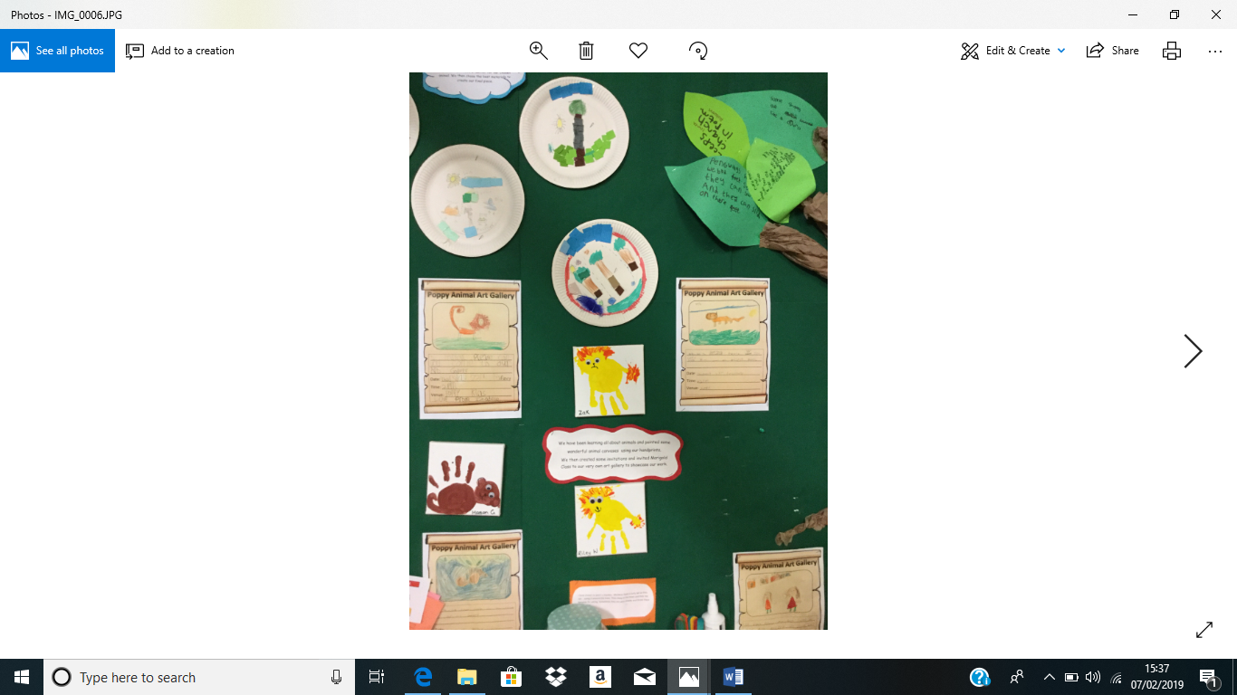
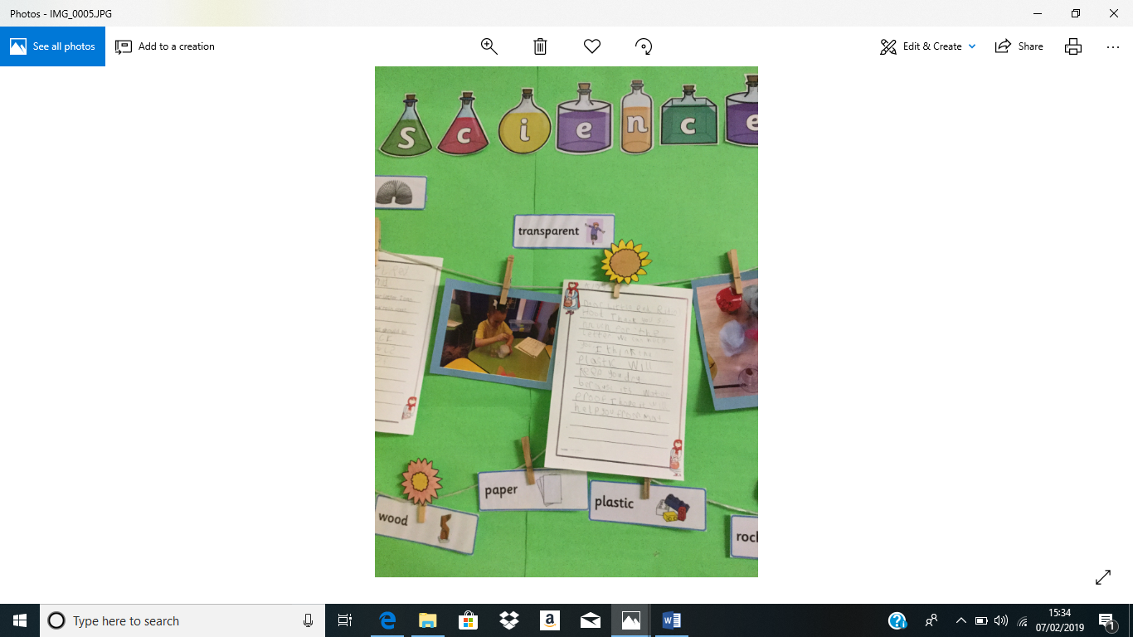
We are very proud of the progress being made across KS1 in writing. The children are given many creative opportunities to write across all curriculum areas.
Scientific writing in year 2!
Super writing in Reception!
Writing across the curriculum in Year 1!

