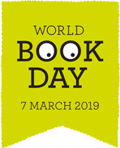
WORLD BOOK WEEK at NETHERTON MOSS!
We are planning lots of exciting activities to celebrate World Book Day 2019 which will take place during week beginning Monday 4th March!
All children will be given a £1 book token which can be swapped for one of twelve World Book Day books.
Or, the token can be used to get £1 off any full price book instead.
Some of the titles are -
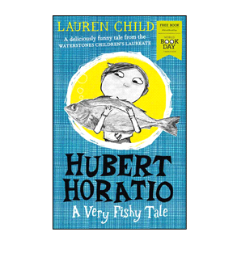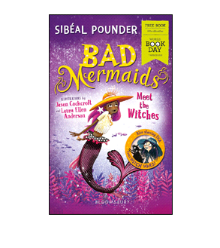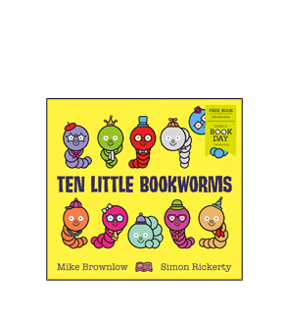

CLASS BOOK SWAP
Bring a book to school which you have read and enjoyed but no longer want - and swap it for another!
WHOLE SCHOOL BOOK STUDY
Throughout World Book Week every class will be focussing on -
The Tin Forest by Helen Ward and Wayne Anderson
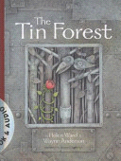

EXTREME READING COMPETITION!
We invite all children to take part in a competition to win a Book Voucher! Think of an unusual place to read and bring a photo into school! The most unusual wins! Examples may be - on top of a slide, up a tree, on a beach, in a boat, in the woods, in a den, in the dark with a torch, in a shop and so on.
BEDTIME READING MUFTI DAY - THURSDAY 7th MARCH!
Our theme this year is Bedtime Stories. We are inviting children and staff to bring one of their favourite bedtime stories to school wearing either a onesie or pyjamas!
.

